Atitit.cateService分类管理新特性与设计文档说明v1

# V2 新特性规划

增加prj属性

增加module 属性

# 分类管理

<http://localhost/good!getGoodTypeInfo.ct>

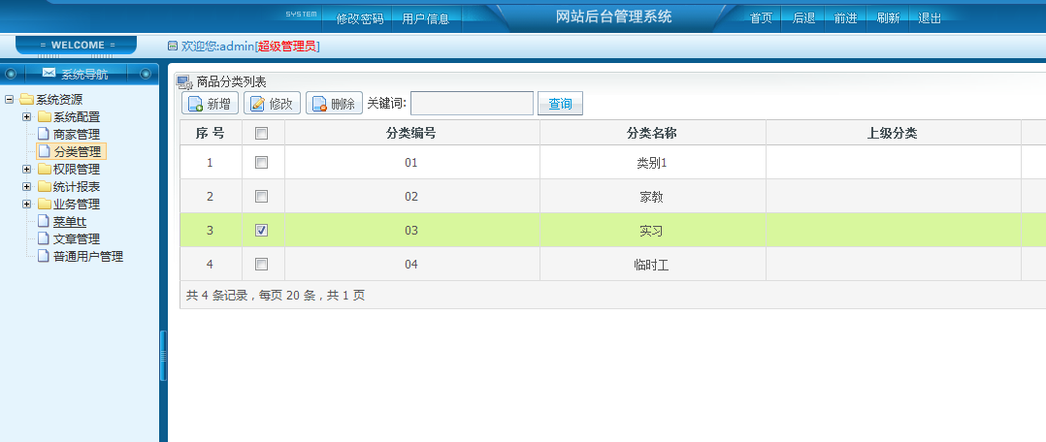

# 分类增加与修改维护

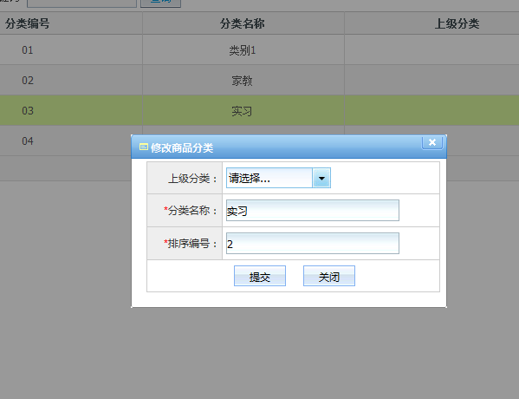

# Js控件分类数据绑定

var cate_ctrl_id="cate_id";

var oxx={"tb":"wxb_good_type","v":"type_id","txt":"type_name"};

var aa={};

var sdb=new SelectDataBinder(cate_ctrl_id,oxx);

function SelecertDataBinder_callback(data)

{

try{

bind_json2select(data,cate_ctrl_id);

}catch(e)

{

showErr(e);

}

}

//////// SelectDataBinder.js

function SelectDataBinder(controlId,p)

{

var sql="select "+p.txt+" as t,"+p.v+" as v from "+p.tb;

logx(sql);

var mp="&$method=com.attilax.sql.SqlService.exe&$callback=page_load_callback&$mod=userMod&$view_store_path=com/attilax/order&$op=insert&param1="+encodeURIComponent(sql);

HRE.exe(mp,SelecertDataBinder_callback);

}